Health Insurance Application

**Banujan Ragunathan**

**Gregory Witmer**

**Lukasz Kaczmarek**

**Andreas Hetschel**

Module: Digitalization of Business Processes

Autumn Semester 2022

**Master of Science in Medical Information Systems**

Inhalt

1 Team Fete des Vignerons 2

2 Description of the use case 3

2.1 Detailed as-is process description 4

3 High Level Process 4

4 Technical Implementation 5

5 Assumptions/Exceptions 11

6 Features 11

6.1 User Task 11

6.2 DMN’s 11

6.3 Check threshold 11

6.4 Analyse the case on ICD 11

6.5 Script 12

6.6 Gateways 12

7 Methodologies 12

7.1 Organisational 12

7.2 Members 12

# Team Fete des Vignerons

This project is a part of the assignment of the module Digitalization of Business Processes in Master of Science in Medical Informatics and Business Information Systems. Students have to digitalise a process and deliver modelling artefacts as Business Process Model and Notation and Decision Model and Notation with the appropriate source file and code. Furthermore, students provide documentation of the complete process and the link to the workflows and instantiations.



# Description of the use case

Cats have been human companions for millennia, and their fanbase seems to be ever and ever rising, with an estimated 1.8 million living in Swiss households in 2022 (<https://de.statista.com/statistik/daten/studie/283732/umfrage/katzen-in-der-schweiz/>).

In this scenario, one cat named “Cat” plays a leading role with his owner Simon. Most of the time, Cat eats, lie around, and explores different environments and areas. Sometimes, Cat can be challenging. Especially, if Simon forgets to feed him. In those cases, Cat tries to get back at his owner. Peculiarly, the cat tries to wake up him in different ways to get fed. Therefore, Cat walks around meowing. Cat intentionally broke a vase, so the loud smashing sound would wake Simon up, but it was not successful. Moreover, Cat climbs onto the cupboard to try to jump on Simon’s face. But suddenly the cupboard falls on Simon and hurts him. This resulted in several injuries on Simon's face, lengthy treatment, and a long stay in the hospital. Finally, Simon receives the medical bill which he passes to his Health Insurance.

The Health Insurance “Medical Health Insurance” shortened MHI is in doubt about the invoice. In general, more and more frauds try to get medical bills paid for all kinds of medical expenses even if they are not a customer of MHI. Furthermore, even the hospitals use incorrect ICDs to get treatment and hospital stays reimbursed which does not rely on the main cause of the admission to the hospital. Therefore, MHI agents check all medical bills in detail by their hands and disputed the invoice by different Medical Codes (e.g., ICD) which were not suitable for that case in relation to the doctor’s documentation. MHI work along with Checkmedical from Bern for further assistance. They are focused on checking medical bills based on their long-term medical experience and support MHI in clearing their fraudulent medical bills.

All previous points were painstaking and lets to time cost. Therefore, the elderly CEO of MHI decided to give digitalization a try, and asked FHNW students to set up the following processes:

* Through an online form, the customer should be able to send in the medical bill with their details
* The system should check automatically if the customer is one of the existing clientele.
* Non-registered customers should be contacted and will be handled as potential customers for the future.
* The system should run through the details of the customer, should check the details, and should give out the percentage of the payment according to the customers insurance type.
* The system should go through the ICD on the medical bill and verifies if the case can be referenced to the case.
* The system should send a mail to Checkmedical company for detailed clearance if the ICD does not relate to the case.
* Medical bills with incorrect ICD will be rejected and the customer and hospital will be informed.
* The payment amount will be calculated if the medical bill reference to correct ICD and to an existing customer.
* The payment amount will be calculated according to the payment percentage (according to insurance policy type) and the full amount of the medical bill.
* As a final part, the customer will be informed about the payment, the case will be registered in MHI-Database and the financial department will be informed to release the payment.

## Detailed as-is process description

Simon likes cats and he travels around the world. His cat is called “Cat” and goes with him everywhere he travels. Most of the time, Cat eats, lies around, and explores. Sometimes, Cat can be challenging. Especially, if Simon forgets to feed him. In those cases, Cat tries to get back at his owner. In particular, Cat tries to do it with tricks. Peculiarly, the cat tries to wake him up in different ways to get fed. Therefore, Cat walks around meowing. Cat intentionally broke a vase, so the loud smashing sound would wake Simon up, but it was not successful. Moreover, Cat climbs onto the cupboard to try to jump on Simon’s face. But suddenly the cupboard falls on Simon and hurts him. This resulted in several injuries on Simon's face, broken bones, lengthy treatment, and long stay in the hospital.

Simon receives the medical bill of 1 Mio. CHF which he passes to his Health Insurance. The Health Insurance “Medical Cat Health Insurance” shortened MCHI is in doubt about the invoice and requests a second opinion in Bern. Checkmedical specializes in checking medical bills for Health insurances. They disputed the invoice by different Medical Codes (e.g., ICD, DRG, Tarpy, Tarmed etc.) which were not suitable for that case in relation to the doctor’s documentation.

Does Simon’s medical bill get paid? On what basis are the invoices rejected from Health Insurance?

# High Level Process

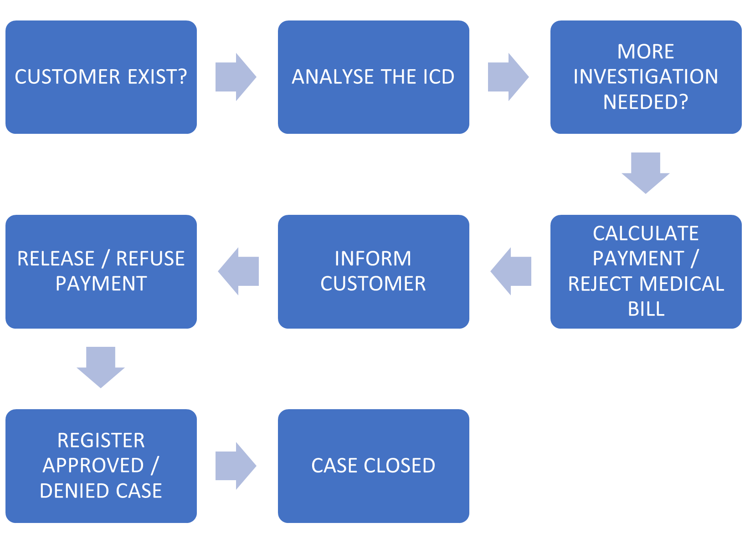

# Technical Implementation

1. Main Process
2. Make

Several components have been used to integrate the scenario to work:

1. Google Cloud Platform & APIs have been configured to work with Make.com through authorization tokens, and specific user group set up:

* Vision API
* Google Spreadsheet
* Google Drive
* Gmail

1. Google Services

* Google Spreadsheets
* 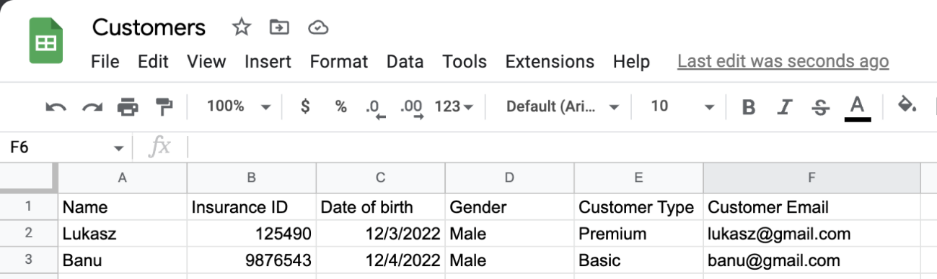Customer database

This database includes information about customers like:

* Name
* Insurance ID
* Date of birth
* Gender
* Customer Type
* Customer Email
* Claims database



This database includes information about customers like:

* Timestamp
* Name
* Insurance ID
* Date of birth
* Gender
* Email address
* Consent
* Bill information
* Amount
* ICD Code
* Preferred Contact
* Bill processing status
* Final amount
* Business key (ID)
* Status

Information in this database is filled by multiple components like Google Form (automatically), Make.com

* Google Drive that stores electronic bills (pdfs) and databases (gSheets)
* Gmail account to send emails
* Google Form to start the process

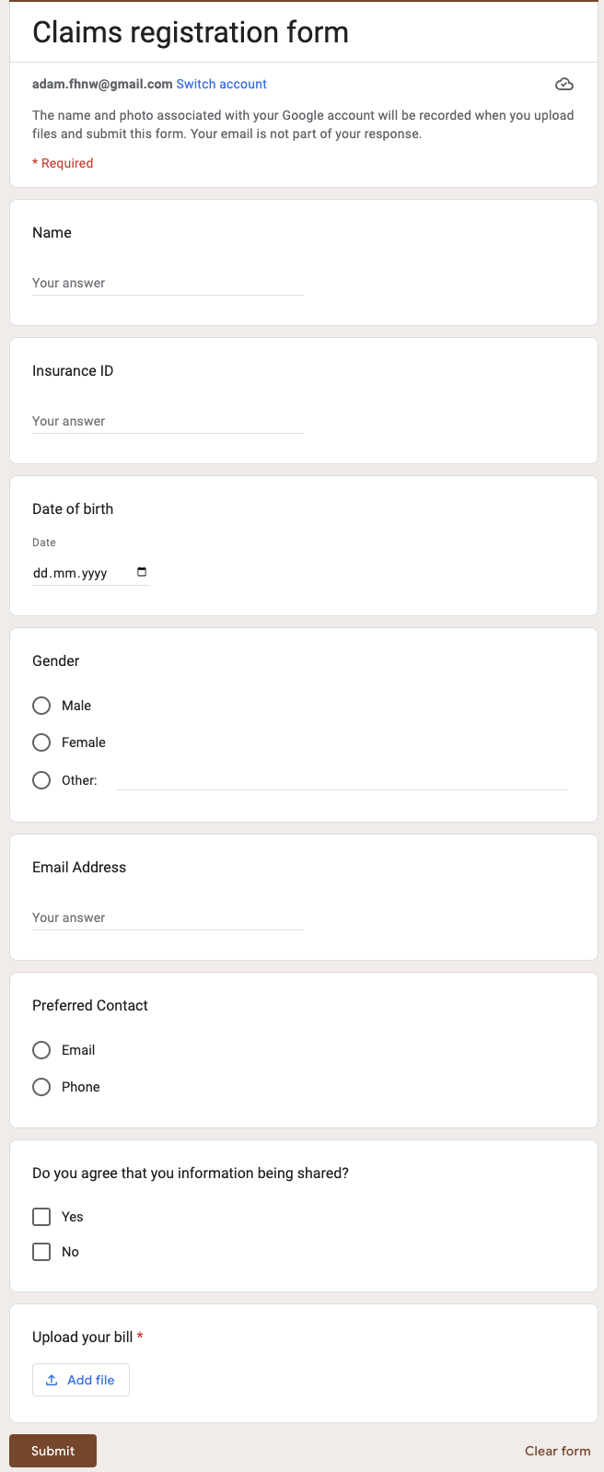

Once customer fills in all the data and upload a bill, the process in Make.com starts:

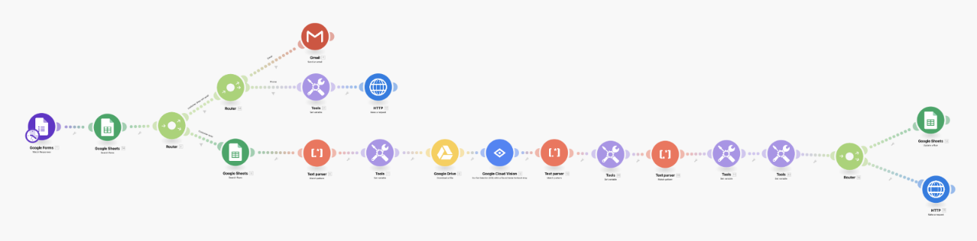

The process looks for new Google Form entries and passes all the details about the customer entry to next phases.

It checks whether the customer exists and sends to specific route based on the results of that check.

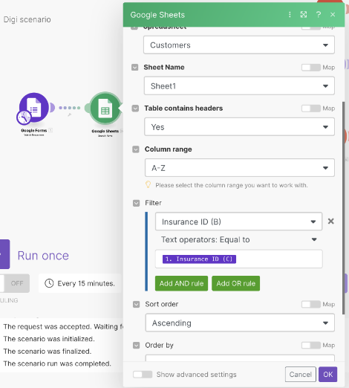

We use the filter on the connection:

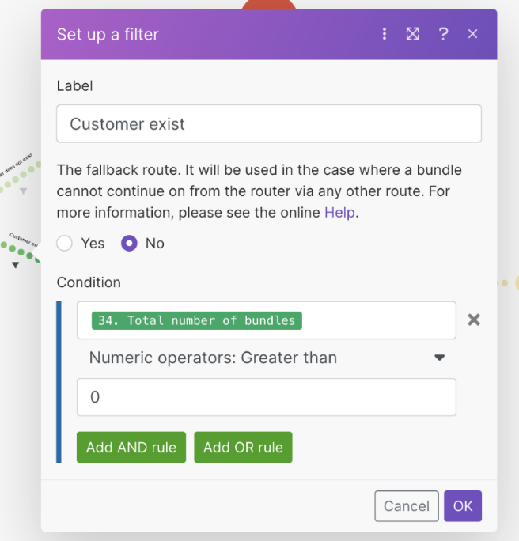

If the customer exists, we take an URL of the bill from Claims database and send the document to go through the OCR process using Google Vision API.

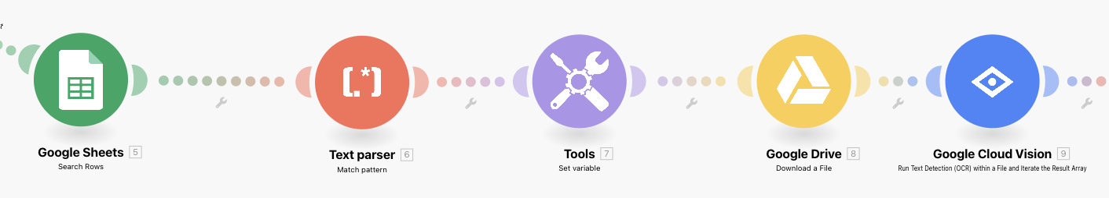

The URL in spreadsheet has to be parsed using regular expression due to incompatibility with Make module.

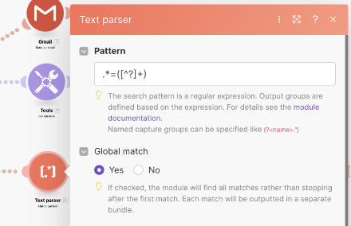

The new variable is created that contains document ID and is sent to Vision module. We use Tools module for that.

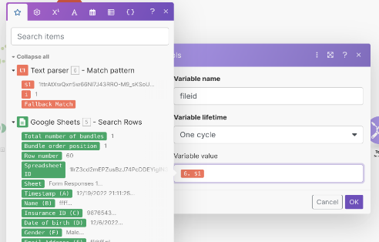

Google Vision module response after the document is read need parsing using regular expressions to find a) ICD code and b) Amount on the bill

A)

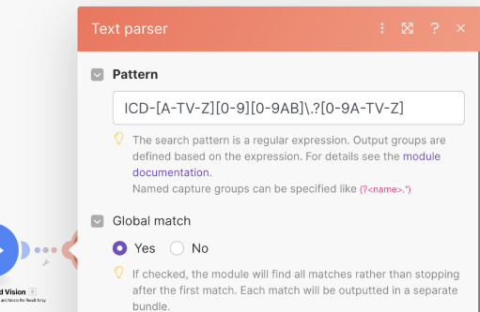

B)

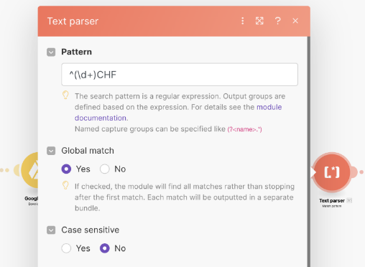

We set up a business key and save it into the claims spreadsheet for particular processed claim and start the process in Camunda with all required parameters:

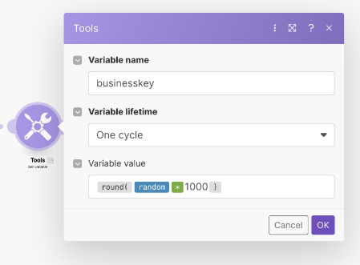

Start the main process in Camunda:

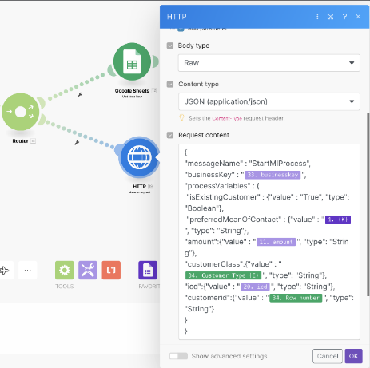

Additionally, if the customer does not exist, we send him/her an email that registration is required (if preferred method of communication is email). If preferred method of communication is Phone, we then start a process in Camunda to invoke a manual user task to call the person.

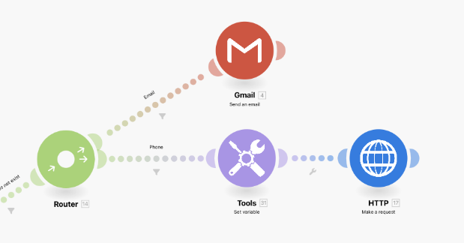

 Additionally, we have established two scenarios in Make.com that take care of sending the customer an email and update the Claim once the process finishes in Camunda. Both scenarios are triggered from Camunda.

1) Inform customer:

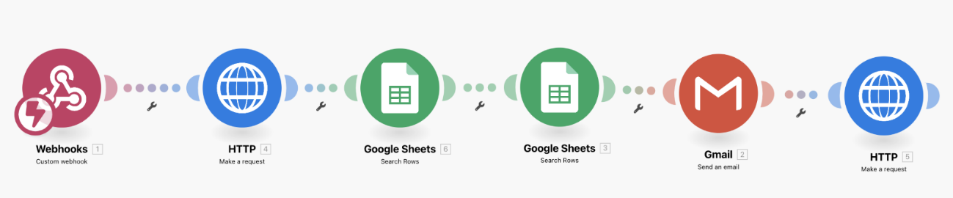

Fetch tasks from Camunda:

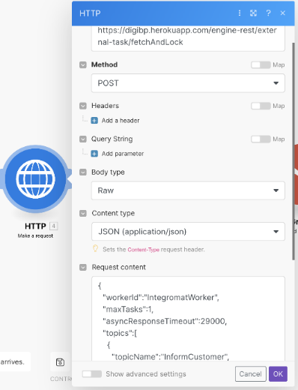

Close topic in Camunda:

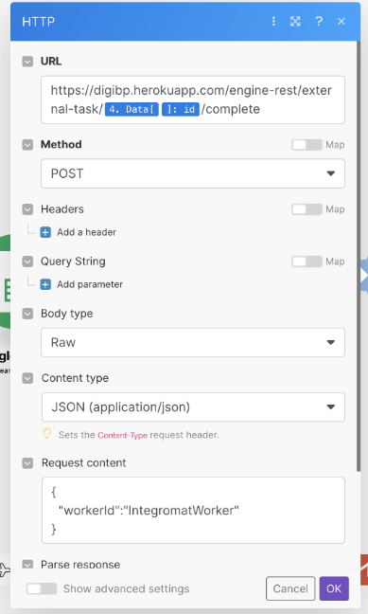

2) Update Claim:

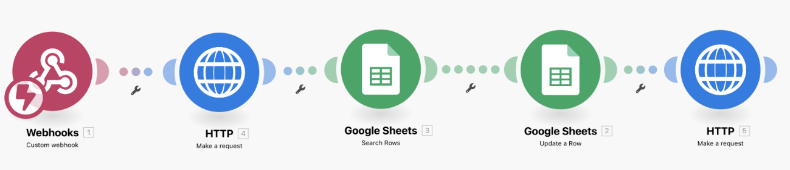

From the communication with Camunda the same actions are happening as in the previous scenario.

Assets:

* [Google Form](https://docs.google.com/forms/d/1vmmVvSznWi9SSz2LaiRyJXIhSCyPMCXEBDu19wikpVA/edit)
* [Google sheet customers](https://docs.google.com/spreadsheets/d/1JH3Oz-mtsA-_Huf3WvgoaZF0hBaFA8Me5qXzu4FzgB0/edit#gid=0)
* [Google sheet bills](https://docs.google.com/spreadsheets/d/1lrZ3cd2mEPZusBzJ74PcDDEYigIN3SgXdZ3agnMSZq4/edit#gid=400047130)

# Assumptions/Exceptions

There are several ICD-Code involved in a real medical case. We focus on one ICD based on Simon’s case in our project and align the automated process mainly to it. So, we have taken one ICD to simplify the process and used a list of correct and incorrect ICDs to compare. Overall, the analyses of ICD will hold simple and easy. We assume in this situation that a medical case has only one ICD on a medical bill.

# Features

## User Task

The user task will be handled directly by the Medical Health Insurance or Checkmedical agents. Therefore, the intern agent of MHI could claim the task in Heroku App. External Partner as Checkmedical receive a mail from MHI.

## DMN’s

There are two different DMN’s in the entire process. These following subparagraphs are going to focus on detail.

## Check threshold

The threshold DMN clusters according to the customer’s type of insurance policy. This part of the process will bring out the refund amount that the customers will receive at the end. The types of insurance policy and refund percentages are Basic (0%), Classic (20%), Middle (40%), Advanced (60%) and Premi-um (80%). The customer must pay 20% of the cost on his own.

## Analyse the case on ICD

The DMN “ANALYSE THE CASE ON ICD” checks if Simon’s case is coherent with the medical bill. Therefore, we used a list of correct and incorrect ICDs to compare. The fake bill will have one ICD attached and this will be scanned with the function OCR. Finally, the ICD will be compared and reveal if a true or false ICD is used in Simon’s medical bill. We have different fake bills to play different conditions through. The explanation of ICDs is given as list in Excel format.

## Script

The script of the process calculates the percentage and the refund amount from the customer. Therefore, the script uses different variables from previous stages and features.

## Gateways

There are several Gateways used in the entire process. The Exclusive Gateways allows us to answer to “YES” or “NO” questions. Therefore, an example is the question if a further check by the Medical Health Insurance needed. A Parallel Gateways take over different task on the same time. A good practice in our case is that customer and hospital will be informed about the cancellation on the same time.

# Methodologies

The project team activated a Teams board to support agile implementation of the project. Initial brainstorming was done using design thinking techniques and literature search supported by external outreach.

## Organisational

It is hosted on Github. Contributions are made via branches. Local commits are pushed regularly. Pull requests (especially into main) have to be approved by a second person, who after approval also merges the branch. Features and Requirements are tracked as Issues on Github. Branch names follow the pattern: <Issue Number>/<Title/Description of ticket in noun form with hyphens> Merge request names follow the pattern: <Requirement- or Issue ID>: <Title/Description of ticket in noun form> Examples: Branch 2/Addition-of-Code-Styles-to-Readme will result in the PR: 2: Addition of Code Styles to Readme Commits always have a commit message in the form of an action. Example: Commit Add commit style to Readme-file into branch 2/Addition-of-Code-Styles-to-Readme.

## Members

* Lukasz Kaczmarek
* Banujan Ragunathan
* Andreas Hetschel
* Grégory Witmer